Course registration form for up to three bookings (Please complete in BLOCK CAPITALS)
Course 1 |  |  | Date:
Course 2 |  |  | Date:
Course 3 |  |  | Date:
Name | First name: Family name:
Date of birth
Address
Postcode
Please indicate whether you want us to write to you confirming course details and directions by post or by email:
By Post: □ |  | By email: □
Mobile: |  | Telephone:
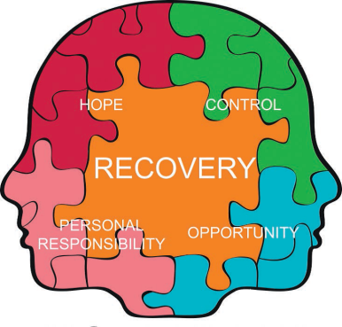 ….
Course registration form (Please complete in BLOCK CAPITALS)
Please outline in brief any difficulty which may make it hard for you to attend or fully benefit from any courses you have registered for. This could connect to mental health, learning difficulty or disability issue.
____________________________________________________________________________
____________________________________________________________________________
____________________________________________________________________________
____________________________________________________________________________
Full name: ________________________________________________
Contact telephone number: ________________________________________________

